**Lab 9**

1. 
2. A computer screen shot of a computer screen

   Description automatically generated
3. 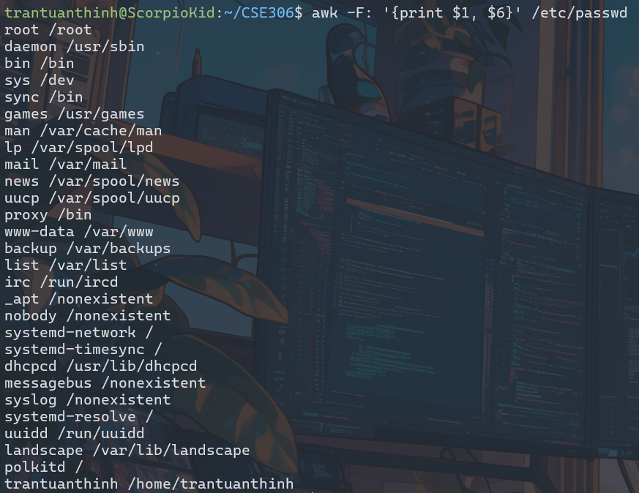
4. 
5. A screenshot of a computer

   Description automatically generated
6. A screenshot of a computer

   Description automatically generated
7. 
8. A screenshot of a computer program

   Description automatically generated
9. A screenshot of a computer

   Description automatically generated
10. A computer screen with text

    Description automatically generated
11. A screenshot of a computer

    Description automatically generated
12. A screenshot of a computer

    Description automatically generated
13. A screenshot of a computer code

    Description automatically generated
14. A screen shot of a computer

    Description automatically generated
15. 